# File permissions in Linux

## Project description

Changing file ownerships effectively limiting who can access them.

## Check file and directory details

cd projects

ls -l

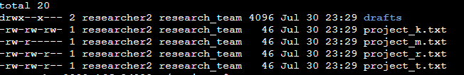

## Describe the permissions string

A 10-character string begins each entry and indicates how the permissions on the file are set. For instance, a directory with full permissions for all owner types would be drwxrwxrwx:

* The 1st character indicates the file type. The d indicates it’s a directory. When this character is a hyphen (-), it's a regular file.
* The 2nd-4th characters indicate the read (r), write (w), and execute (x) permissions for the user. When one of these characters is a hyphen (-) instead, it indicates that this permission is not granted to the user.
* The 5th-7th characters indicate the read (r), write (w), and execute (x) permissions for the group. When one of these characters is a hyphen (-) instead, it indicates that this permission is not granted for the group.
* The 8th-10th characters indicate the read (r), write (w), and execute (x) permissions for the owner type of other. This owner type consists of all other users on the system apart from the user and the group. When one of these characters is a hyphen (-) instead, that indicates that this permission is not granted for other.

## Change file permissions

chmod o-w project_k.txt

ls -la

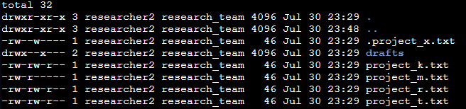

## Change file permissions on a hidden file

chmod u-w,g-w,g+r .project_x.txt

ls -la

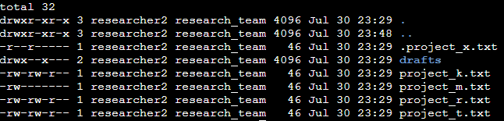

## Change directory permissions

chmod g-x drafts

ls -la

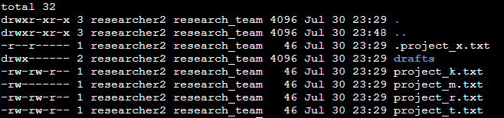

## Summary

In this project, I showcased my proficiency in managing file and directory permissions using the Linux command line.

Key aspects of the project included:

* Understanding file permissions and ownership levels.
* Using "ls -la" to view permissions.
* Modifying file permissions using "chmod."
* Applying concepts to regular and hidden files.
* Managing directory permissions.

This project solidified my understanding of Linux command-line permissions management.